What Is Dopamine?
Dopamine is an important neurotransmitter, which are the body's chemical messengers responsible for facilitating communications between nerve cells in the nervous system (which includes the brain, where dopamine functions). Specically, dopamine is most commonly associated with the brain's pleasure and reward system. It also plays a role in controlling movement.
Dopamine can be found in two different areas of the brain. The rst is the substantia nigra, which plays a role in both rewards and movement. The dopamine in the substantia nigra is the cells that die when someone has Parkinson's disease, which causes the tremors and other mobility difculties that are characteristic of the condition.
Most of the dopamine in your body is produced in the ventral tegmental area (VTA) of the brain, which is a main player in the brain's pleasure and reward signaling. Dopamine is created in the VTA and then released into other areas of the brain when someone does something that warrants a reward or pleasure response, or even when a person just anticipates a reward. Though most people associate a "reward" in the brain with behaviors like drug use or sex,

dopamine also responds to behaviors that we need to survive, like Grief
eating or drinking water.
About Advice FAQ Reviews Counselor Jobs Contact Guilt
Get started
Login
Humans need to experience some sort of a reward response through dopamine for these necessary behaviors in order to motivate us to keep doing them. Releasing dopamine and causing us to feel pleasure from these things is our body's mechanism to ensure that we continue to do things that we need to do in order to keep the body running optimally and feel healthy.
Dopamine vs. Serotonin
Dopamine is often grouped with another neurotransmitter, serotonin. While the two neurotransmitters do have some similarities in that they are both chemical messengers for the brain and both have positive associations in regards to mood, their core functions are quite different. Dopamine brings about positive feelings based on a certain action. Serotonin, on the other hand, functions more as a mood stabilizer. However, a deciency in either serotonin or dopamine can negatively affect mood and happiness.
Happiness
HowTo
Huntington's Disease Impulse Control Disorder Intimacy
Source: commons.wikimedia.org
What Does Dopamine Do?
Dopamine's two primary functions are motivation and movement. But, dopamine also plays a role in other cognitive functions such as memory and focus.
Dopamine And Movement
As previously mentioned, dopamine produced in the substantia nigra (part of the basal ganglia region of the brain) helps control movement. The basal ganglia control many aspects of bodily movement and rely on the secretion of dopamine from dopamine- containing neurons to function properly. Thus, dopamine is necessary for the controlled movement to occur in its normal fashion.
Phobias Pornography Procrastination Psychiatry Psychologists Psychopathy Psychotherapy PTSD Punishment Rejection Relationships Resilience
Self Esteem Sleep Sociopathy Stage Fright Stereotypes Stress
Success Stories Synesthesia Teamwork Teenagers Temperament Tests
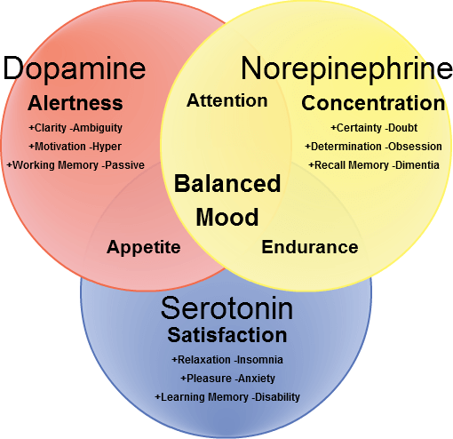
But, sometimes this facilitation is disrupted, and not enough
About Advice FAQ Reviews dopamine reaches the substantia nigra and basal ganglia. When this
happens, movement and control of movement and motor functions
Therapy
are greatly reduced. One of the main symptoms of Parkinson's disease is delayed, or uncontrollable movements, which researchers have found is caused by a lack of dopamine in the substantia nigra.
Contrastingly, sometimes the basal ganglia are overloaded with too much dopamine. While a lack of dopamine restricts movement, too much dopamine can cause the body to make too many movements. These uncontrolled, unnecessary movements are a common characteristic of Tourette's syndrome.
Dopamine, Pleasure, And Rewards
Dopamine is the primary neurotransmitter involved in the brain's rewards system and feelings of pleasure. When someone engages in behavior the brain perceives as pleasurable, such as eating, dopamine is released, and the behavior is signaled as one that merits a reward. This motivates the person to perform the behavior again in the future. One of the other common triggers of dopamine is sex. Sexual intercourse sparks the release of dopamine, along with hormone and neurotransmitter oxytocin. These two things are what causes the euphoric feelings around sex, and contribute to the human desire to engage in sexual intercourse.
While the reward system is designed to motivate us to carry out behaviors that benet our health, it can also motivate certain harmful behaviors when dopamine is articially stimulated. One example of this is cocaine. This drug blocks the reuptake of dopamine, meaning that the brain's synapses are ooded with an unusually high amount of the neurotransmitter. This excess of dopamine leads to the euphoric feeling one may experience after using the drug. But, it also interferes with the brain's natural dopamine system and can disrupt its normal cycles.
Despite feeling unusually euphoric immediately after using cocaine,
About Advice FAQ Reviews Counselor Jobs Contact in the long run, it causes someone to feel worse because the
dopamine system does not function as it should. The brain responds
to the extremely high levels of dopamine released due to drugs by naturally producing less dopamine on its own.
Dopamine And Addiction
The rush of dopamine experienced when using cocaine and other drugs also contributes to drug addiction. Because the brain experiences extremely high amounts of dopamine when someone uses drugs, using the drug becomes associated with rewards and pleasure. This means the person will be motivated to repeat the behavior to experience the same reward. Unfortunately, this can rope someone into the cycle of addiction.
Not only does someone become addicted, but they also will want to use higher amounts of the drug. The brain builds a tolerance to the drug and produces less dopamine when the person uses it, so they will have to use more and more of the drug to feel the same rush of dopamine as they did upon initially using. Keep in mind that drugs can cause a release of two to ten times more dopamine than natural triggers like eating or sex.
Source: commons.wikimedia.org
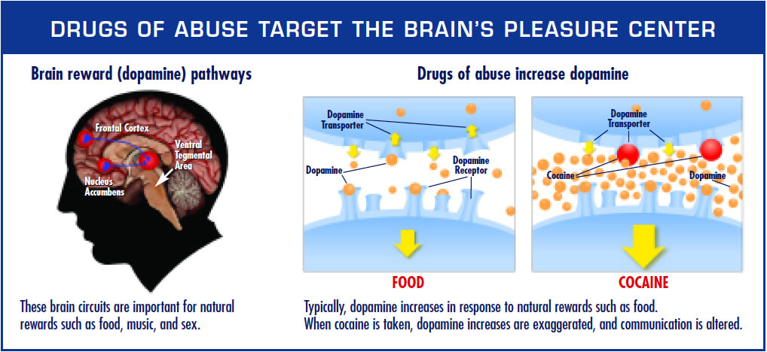
The dopamine cycle is just one of the reasons why breaking an
About Advice FAQ Reviews Counselor Jobs Contact addiction is so incredibly challenging. Most people cannot overcome
addiction on their own. A therapist or counselor can be a great
person to have as part of your support system if you are struggling with addiction.
Dopamine And Memory
One of the lesser known dopamine functions is its role in memory. Though dopamine is not produced in the prefrontal cortex area of the brain, dopamine secretions in that area help facilitate memory processing. This is a highly delicate function of dopamine, so even the slightest variation in the number of dopamine secretions in the area can severely impact one's memory.
Dopamine can also be blamed for why we tend to remember things that interest us better than things we are not interested in. When something is interesting to us or excites us, we get a spike of dopamine because the experience of learning about that thing is pleasurable. The dopamine secretes in the prefrontal cortex, so our memory is activated, and we are more likely to remember the thing we are learning about. When we nd the subject of focus boring, we do not have the same dopamine spike, so there is less dopamine in the prefrontal cortex, and thus it is harder for us to remember what we learned.
Teachers can greatly benet from this information, because it may explain why students are not absorbing information. Teaching in a way that stimulates students and invokes the brain's reward center, by having students participate in an activity or another engaging teaching method, can help students better remember the information.
Dopamine And Focus
Another dopamine function that teachers may want to be aware of is its role in focus and attention. Dopamine responds to the optic
nerves (those used for vision) to help someone focus their attention
About Advice FAQ Reviews Counselor Jobs Contact on a specic activity. When visually focusing on something, dopamine
low levels of dopamine in the prefrontal cortex may contribute to attention decit disorder.
Dopamine And Happiness
As previously mentioned, dopamine is sometimes confused with another neurotransmitter, serotonin. Unlike serotonin, dopamine does not directly help control mood. However, it can still somewhat inuence moods and emotions. Because it can bring about feelings of pleasure, dopamine is associated with feeling satised with a certain event or one's life in general, which certainly can inuence one's happiness.
Some research also suggests that dopamine may play a role in depression. Whatever the cause of depression may be, therapy or counseling is a great tool for many people to manage their condition better.
Dopamine And Sleep
Dopamine helps us feel more awake, and the body naturally produces more of it during daytime hours when we are more stimulated. As night falls, dopamine levels fall as well, helping us feel tired and ready for bed. People with low dopamine or with conditions such as Parkinson's, which is associated with low dopamine levels, may feel chronic tiredness during all hours of the day.
Dopamine Medications
Because dopamine inuences so many bodily functions, it can be taken as medication to treat certain conditions. Dopamine medications fall into one of two categories: agonists and antagonists.
Dopamine agonists activate dopamine receptors to increase how much dopamine is absorbed in certain areas of the brain. For this
reason, dopamine agonists can be used to treat conditions associated
About Advice FAQ Reviews Counselor Jobs Contact with a dopamine deciency, such as Parkinson's disease. They can be
used to treat other disorders associated with irregular movements
Get started
Login
too, such as restless leg syndrome. A specic type of dopamine agonist medications, indirect agonists, are sometimes used to treat attention decit disorders, which may be related to low dopamine levels in the prefrontal cortex.
Source: commons.wikimedia.org
Dopamine antagonists serve the opposite function and block dopamine receptors. This prevents reuptake of the neurotransmitter and is useful for regulating levels of dopamine. Dopamine antagonists are most commonly used to treat psychiatric disorders like bipolar disorder or schizophrenia.
For most people, dopamine functions as it should without the help of an agonist or antagonist medication. The brain, and thus the rest of the human body, is inuenced by dopamine every day. Understanding the function of dopamine can help you get a better grasp on the brain and human body as a whole.

